University of Georgia
ResearchMatch.org Researcher Request Form

Complete and submit this form to request the use of ResearchMatch.org (RM) as a recruitment tool in your new IRB submission or as a modification to a previously approved IRB study. Please refer to UGA’s ResearchMatch Researchers Guidance for additional information.
VERY IMPORTANT: Before you proceed with completing this form, please note that only clinical, biomedical, translational and socio-behavioral research studies with health-related outcomes or focus are eligible to use ResearchMatch as a recruiting tool. By submitting a request to use ResearchMatch as a recruitment tool, the researcher is agreeing that additional information about the study may be shared with ResearchMatch staff at Vanderbilt University, if necessary.

IRB Study #:
Title of Study:
Complete Name of PI:
- Is this a clinical, biomedical, translational or socio-behavioral research with health-related outcomes or focus?
NO. If No, STOP – Your study is not eligible to use ResearchMatch as a recruitment tool.
YES. If Yes, describe your study’s health-related outcomes or focus: Click here to enter text.

- Name of person completing this form: Click here to enter text.

- Names of all IRB-approved research team members who will be involved with this recruitment tool: Click here to enter text.
- Contact message you will send to potential volunteers (maximum character length is 2000): NOTE: This Contact Message must not include the name of the Principal Investigator (PI) or the PI’s lab, the Study Team Members, and any contact information (such as emails, telephone numbers, and hyperlinks/URLs). See additional information and examples on next page.
Click here to enter text.

- Will you be entering a URL into RM for a REDCap pre-screening (to determine eligibility) survey?
NO
YES. If Yes, include the pre-screening survey in this IRB submission if not previously IRB approved. NOTE: The REDCap pre-screening survey must be IRB approved.

***Additional Information on Contact Messages
Contact Messages sent to eligible volunteers through ResearchMatch usually have a brief description of the study, information about who is eligible, and what is required of participants. Contact Messages cannot contain the name and direct contact information of PI or study research personnel (phone number and email) or URLS/links to lab webpages.
The Contact Message must be approved by the IRB and used ad verbatim when registering your study on the ResearchMatch website. The Contact Message must match all the information in the IRB Submission (e.g., eligibility criteria, recruitment materials, and consent documents), be written in a layperson’s language, and limited to 2,000 characters (including spaces).
Examples of Contact Messages (provided by RM) --
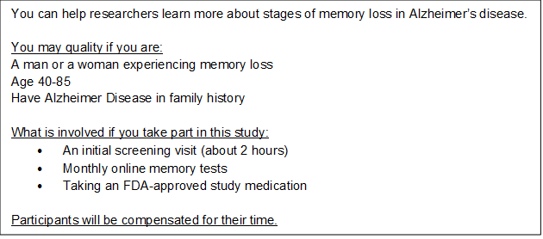
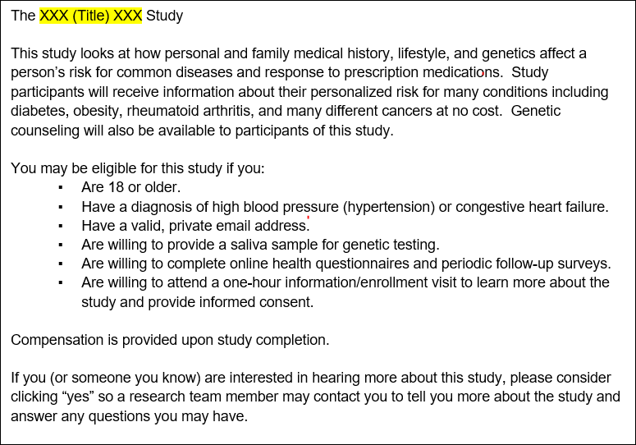
Contact Message Content Description: ResearchMatch provides standard notification language (below in grey) that will be received by all RM volunteers who may be a match for a given study.
